**Little Big Planet 3:**

Challenges: Has a lot of moving pieces and props, heavy scripting

**Full Gameplay:**

<https://www.youtube.com/watch?v=fs59eme0DVA>

**Potential Scenes/Stages:**

* **Zigarat Grand Hall:** colorful, with rhythmic animations all around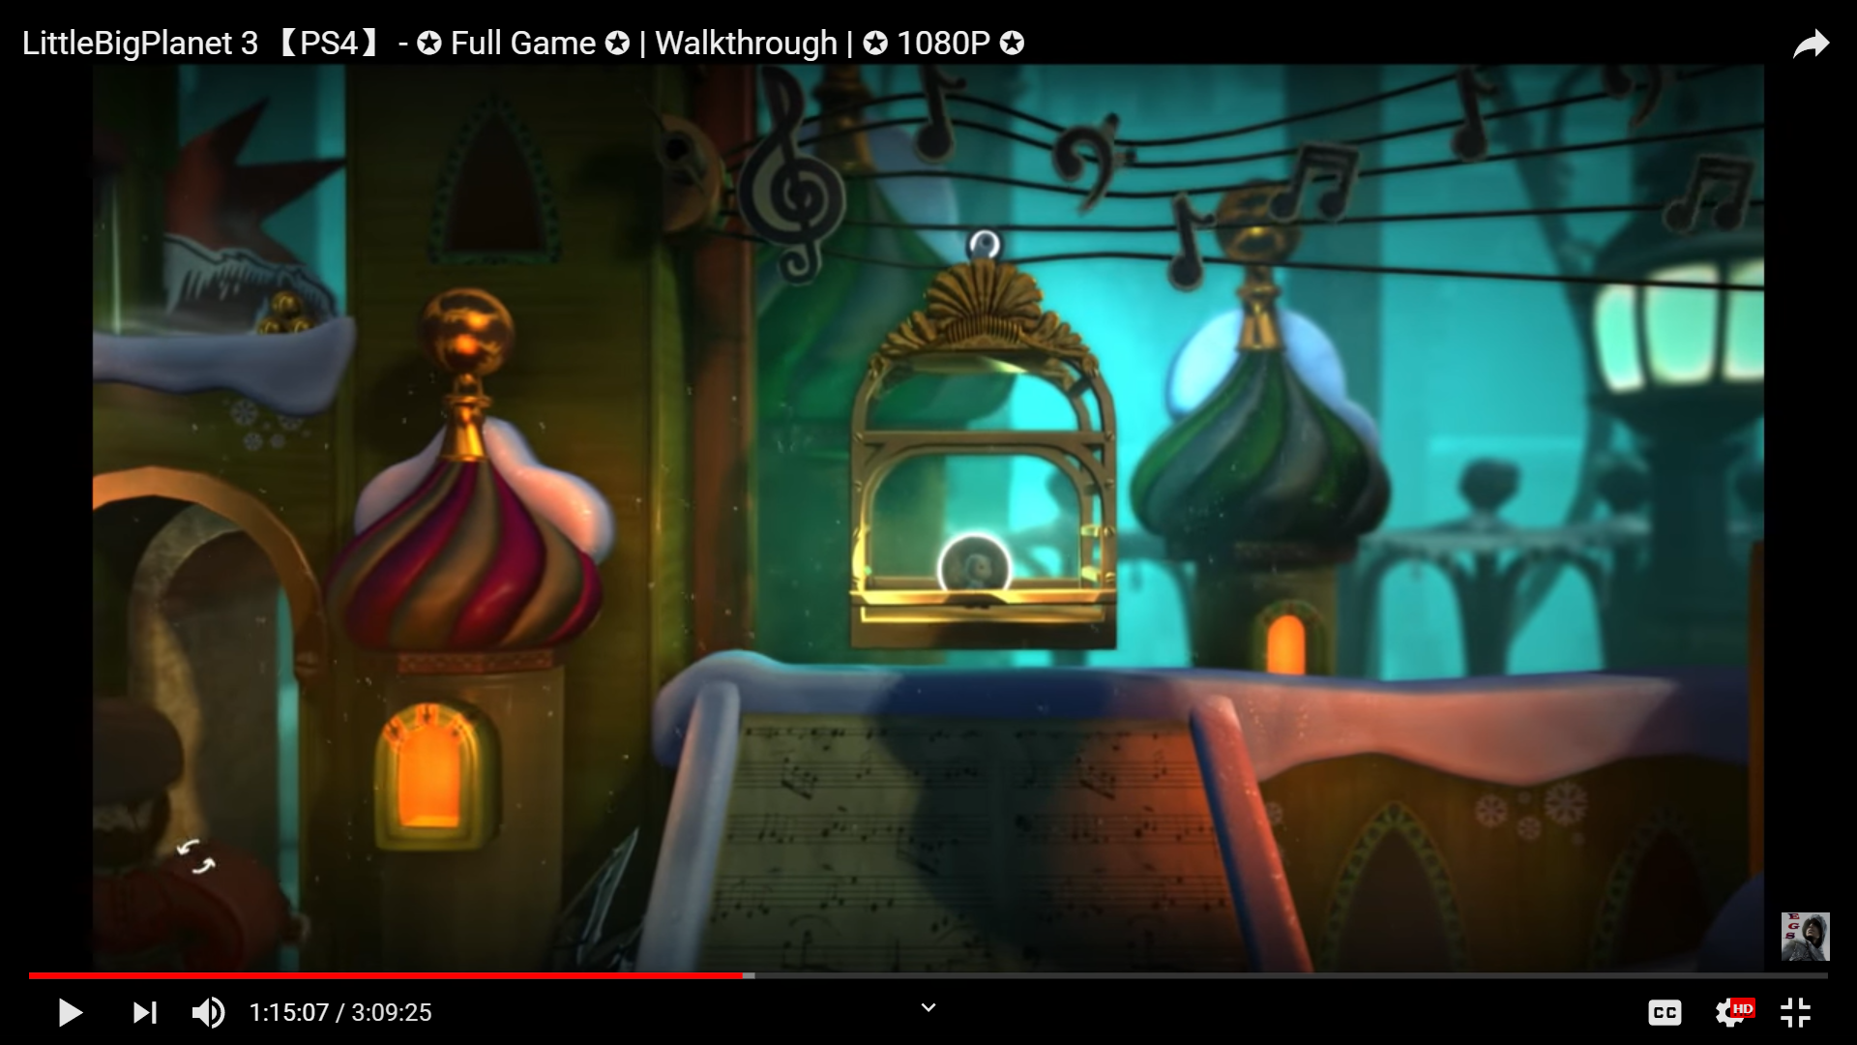

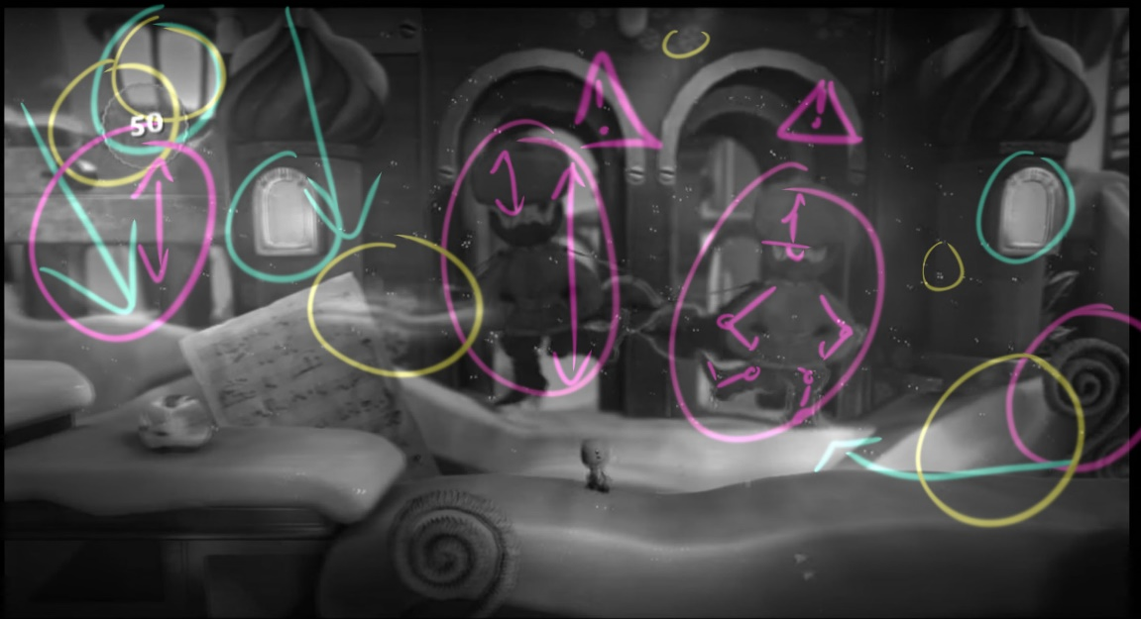

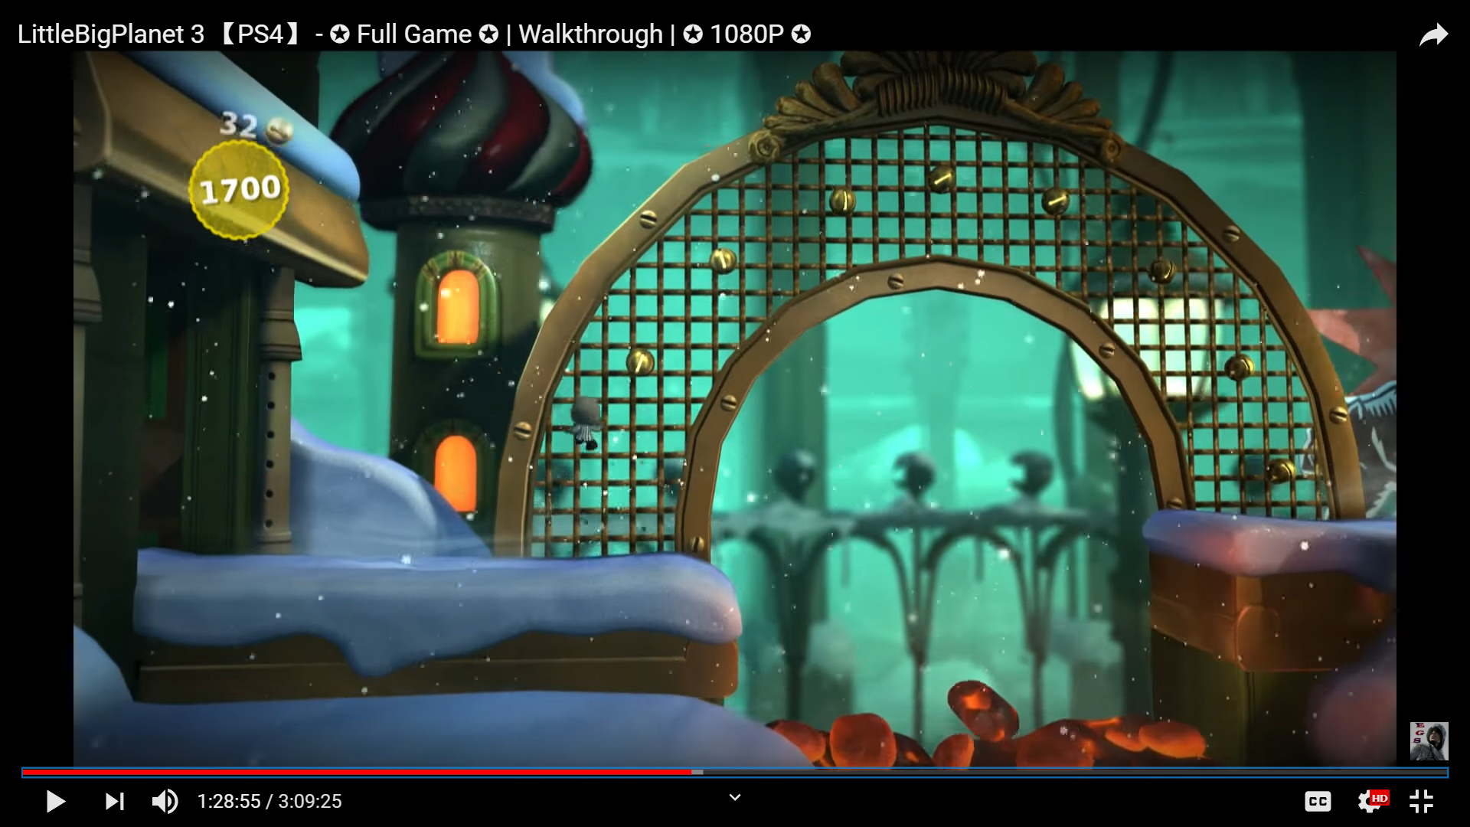

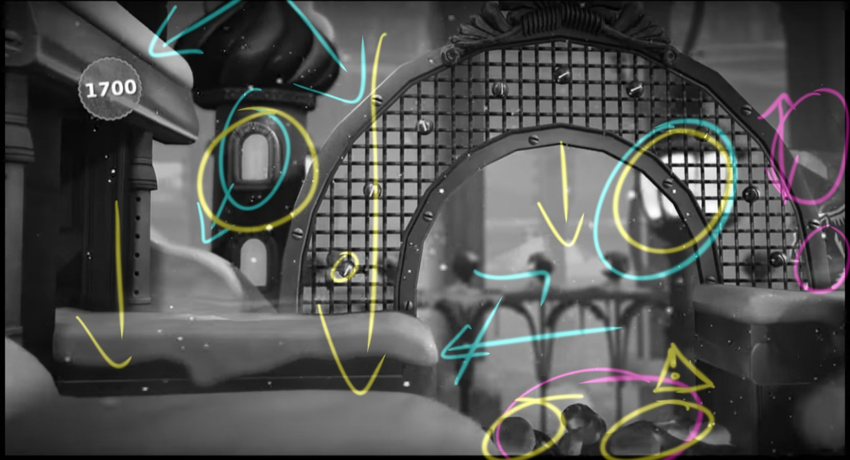

* Flipped Flopped Folios: 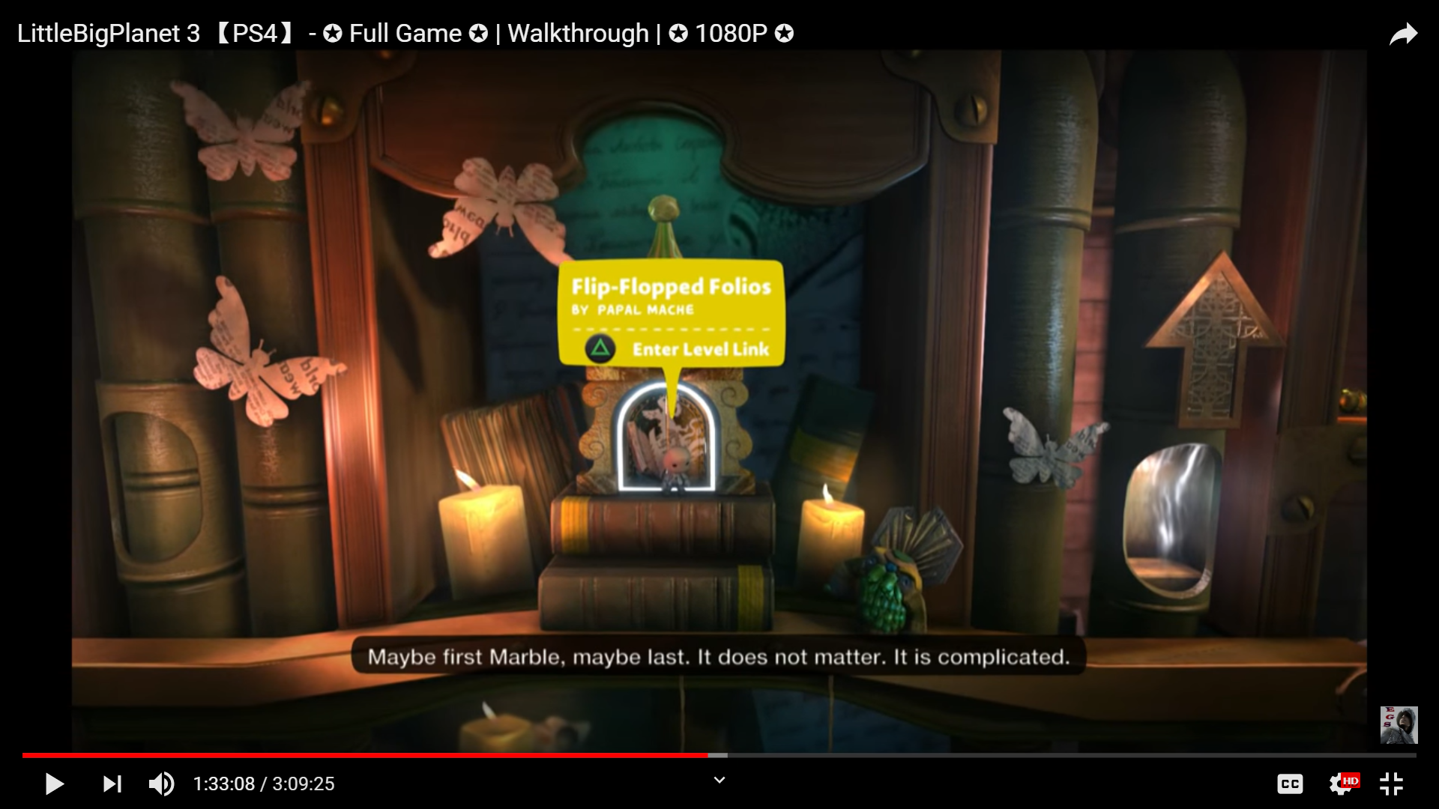

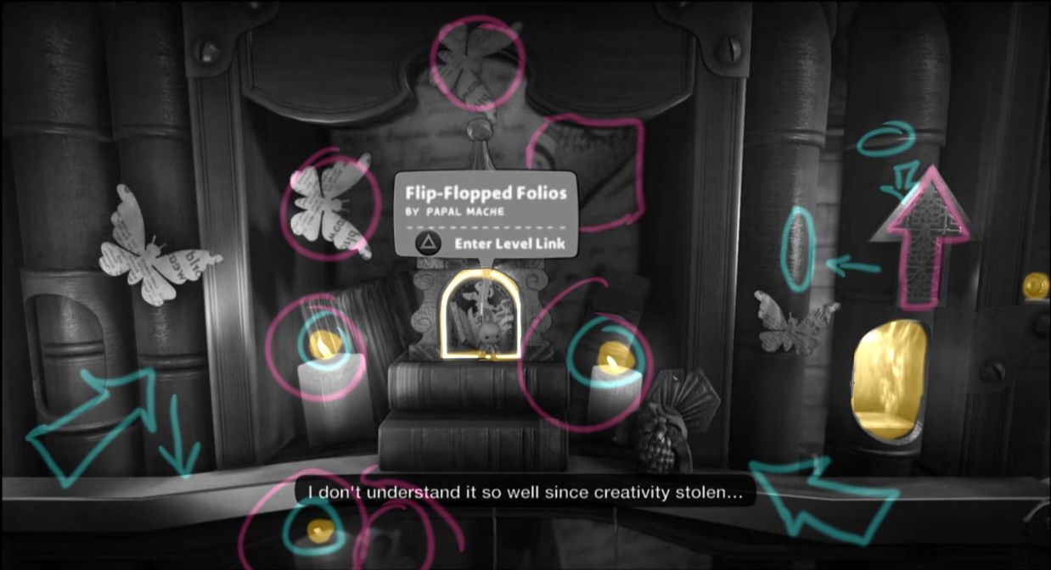

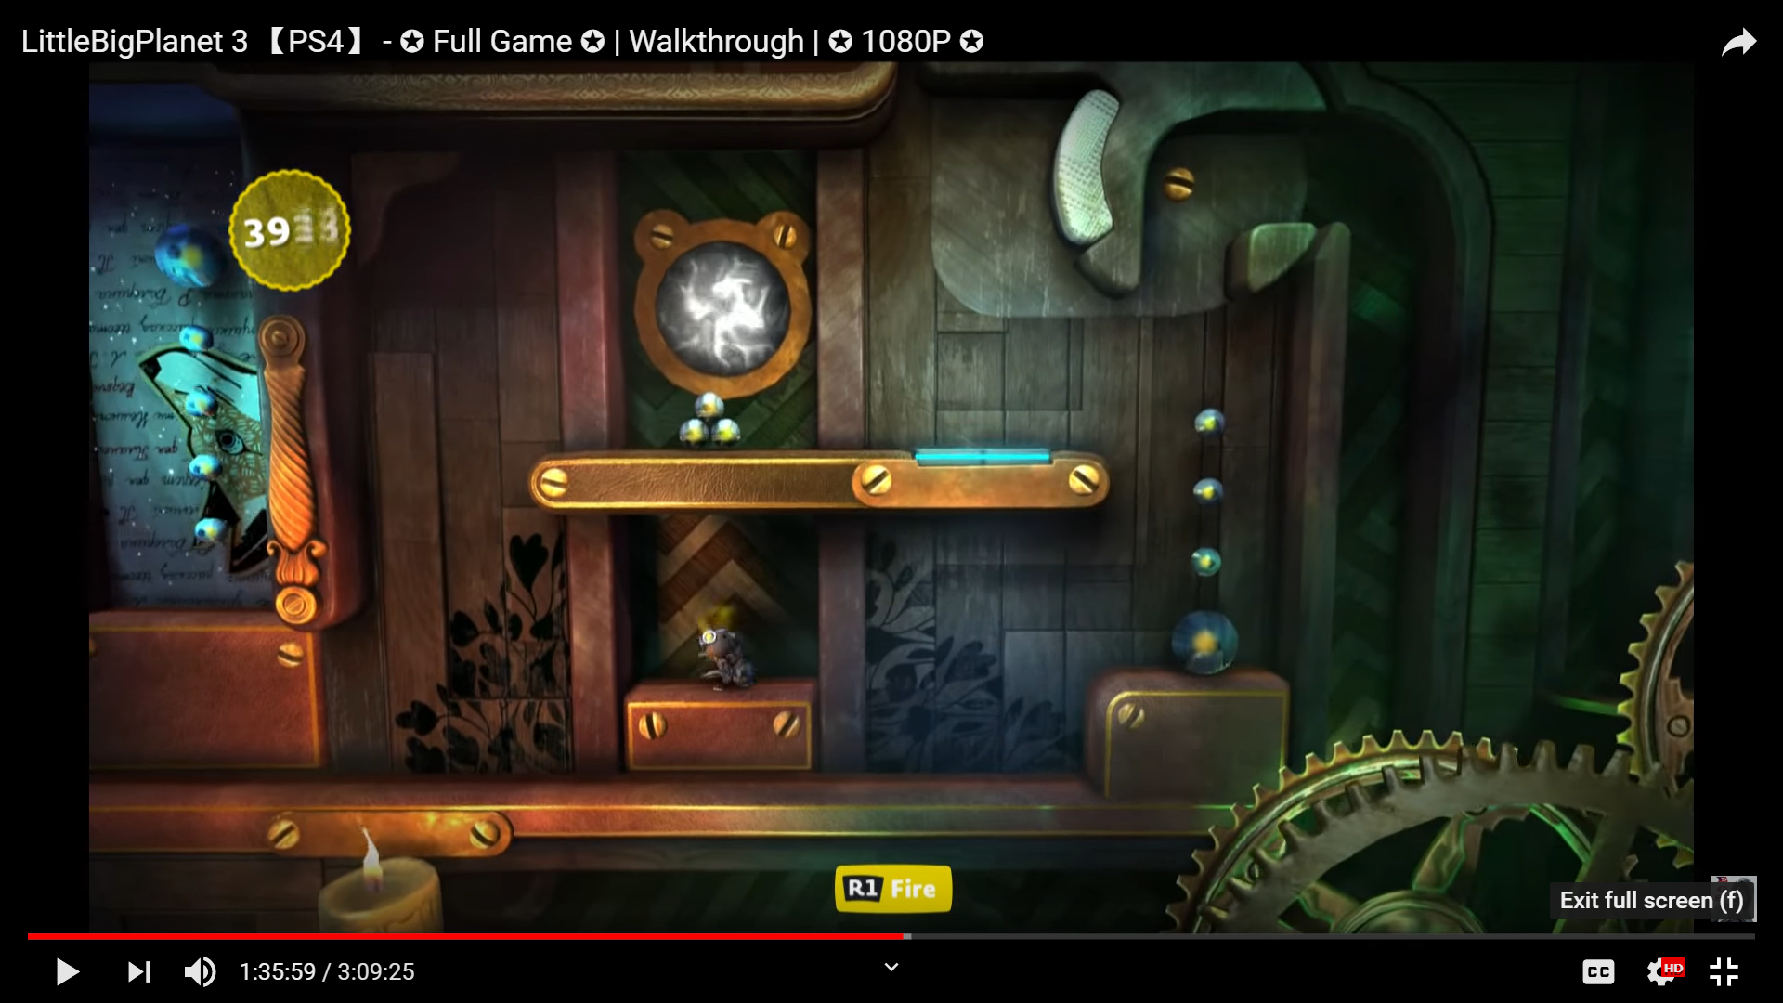

* New Heights:

